Tutorial 7

1. An example of a shift register program is given by the following **figure** 1:

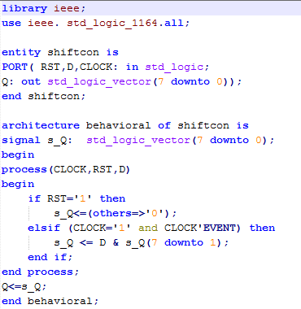

**Figure 1:** 8-bitShift Logical Right Register

1. Write a testbench that can display the following output (**Figure 2**)

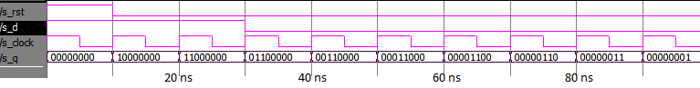

**Figure 2**

1. Modify the code given in Figure 1 to satisfy the behaviour of table 1. The program will shift logical right if the mode input is equal to 00, shift left when mode is equal to 01 etc. Then, write testbench to test all *modes*.

Table 1

|  |  |
| --- | --- |
| **Mode** | **Behavior** |
| 00 | Shift Logical Right |
| 01 | Shift Left |
| 10 | Rotate Right |
| 11 | Rotate Left |

Example

|  |  |
| --- | --- |
| [https://upload.wikimedia.org/wikipedia/commons/thumb/5/5c/Rotate_left_logically.svg/300px-Rotate_left_logically.svg.png](https://en.wikipedia.org/wiki/File:Rotate_left_logically.svg)  Logical left shift one bit | [https://upload.wikimedia.org/wikipedia/commons/thumb/6/64/Rotate_right_logically.svg/300px-Rotate_right_logically.svg.png](https://en.wikipedia.org/wiki/File:Rotate_right_logically.svg)  Logical right shift one bit |

|  |  |
| --- | --- |
| [https://upload.wikimedia.org/wikipedia/commons/thumb/0/09/Rotate_left.svg/150px-Rotate_left.svg.png](https://en.wikipedia.org/wiki/File:Rotate_left.svg)  Left circular shift or rotate | [https://upload.wikimedia.org/wikipedia/commons/thumb/3/37/Rotate_right.svg/150px-Rotate_right.svg.png](https://en.wikipedia.org/wiki/File:Rotate_right.svg)  Right circular shift or rotate |